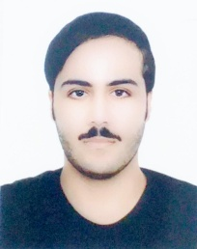**Curriculum Vitae**

**Nedhal Zuhair Ali Ahmed**

**Home: 1151 / Road: 8122**

**Complex: 482**

**Mobile: 36686709**

**Email: nedhal.zuhair1998@gmail.com**

**Manama, Kingdom of Bahrain**

**Career Objective:**

**Seeking a career in an organization that provides mean environment where I can share my knowledge and skills, improving myself by dedicating my vision and mission for service of humanity.**

**Personal Profile:**

* **Nationality : Bahraini**
* **Date of Birth : 12.09.1998**
* **Gender : Male**
* **Marital Status : Single**
* **Language Known : Arabic, English**
* **Driving License : Valid in Bahrain**

**Education Qualification:**

* **2004-2008 Saar Primary Boys School**
* **2009-2010 Jaber Bin Hayan Primary Boys School**
* **2011-2013 Al Duraz Preparatory Boys School**
* **2013-2015 Ahmed Al-Omran Boys Secondary School**

**Strength:**

* **Problem Solving.**
* **Positive thinking.**
* **Hard-working.**
* **Co-operator.**
* **Communicator.**

**Education Qualification:**

**I hereby declare that the above given particulars are true to the best of my knowledge and belief.**